Task 1:

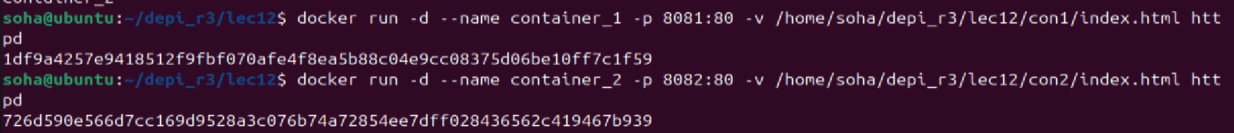



Task2:

Compose.yaml:





